AI-Estimated online product review based on the comments of the customer

Dr. Sampath Kumar Tallapally

School of computer science &

Artificial Intelligence

SR university

Warangal, Telangana State, India

t.sampathkumar@sru.edu.in

Mohammed Ibrahim Afnan Ahmed

School of computer science &

Artificial Intelligence

SR university

Warangal, Telangana State, India [afnanahmed.md@gmail.com](mailto:afnanahmed.md@gmail.com)

Bheem Reddy Devika

School of computer science &

Artificial Intelligence

SR university

Warangal, Telangana State, India bheemreddydevika2003@gmail.com

Eppakayala Rishith Raj

School of computer science & Artificial Intelligence

SR university Warangal, Telangana State, India

[rishithrajeppakayala53@gmail.com](mailto:rishithrajeppakayala53@gmail.com)

Vangara Sairam

School of computer science &

Artificial Intelligence SR university

Warangal, Telangana State, India [vangarasairam2003@gmail.com](mailto:vangarasairam2003@gmail.com)

Thumma Pavan Kumar

School of computer science&

Artificial Intelligence

SR university

Warangal, Telangana State, India [tpavankumar279@gmail.com](mailto:tpavankumar279@gmail.com)

***Abstract*—** *The primary objective of “AI-powered product review summarization” is to efficiently analyze large volumes of product reviews, estimating positive and negative sentiment specific to a product identified by its product name. Using the Text Blob library for sentiment analysis and NLTK for summary generation, the tool increases the ease of analysis and simplifies decision-making processes for sellers and consumers. Desired outcomes include time investment, an informed customer base, and ultimately a reduction in the purchase of defective products. By categorizing sentiment and generating concise summaries, the tool equips users with valuable insights, streamlines the review analysis process, and contributes to a more efficient and trustworthy e-commerce marketplace***.**

*Keywords— Machine Learning, Natural Language Processing, Sentiment Analysis, E-commerce, Review Analysis, Decision-Making*

1. **INTRODUCTION**

In today's ever-expanding e-commerce realm, consumers encounter a flood of product options and information, often leading to decision-making dilemmas. Online product reviews, while a powerful tool for informed choices, paradoxically add to the complexity. The sheer volume of reviews overwhelms rather than guides, prompting a surge in research to tackle this challenge. Enter artificial intelligence (AI), the linchpin transforming how users navigate this deluge.

This groundbreaking solution aims to redefine consumer interaction with product reviews. It harnesses cutting-edge natural language processing (NLP) techniques, not only condensing verbose reviews but also gauging the overall sentiment and product quality. What's more, it crafts concise

summaries, offering consumers a rapid grasp of a product's key aspects, its merits, and demerits.

Central to this innovation are three powerhouse algorithms: Random Forest, Long Short-Term Memory (LSTM), and Recurrent Neural Network (RNN). These algorithms work in tandem, each contributing its unique prowess. Random Forest excels in handling complex data, while LSTM and RNN shine in understanding and processing sequential information, vital for parsing and summarizing lengthy reviews. By amalgamating AI and sophisticated algorithms, this system empowers consumers to cut through the review clutter, enabling swifter, more informed decisions in the bustling e-commerce arena.

Text Blob and NLTK (Natural Language Toolkit) are two popular Python libraries for natural language processing (NLP) tasks, including text summarization. While Text Blob provides a higher-level interface for common NLP tasks, NLTK offers a comprehensive set of tools and resources for more fine-grained control over various NLP tasks.

1. **LITERATURE REVIEW**

Modern technology brings fresh possibilities, software, and technological innovation that can be utilized for marketing and trade. Future technologies force companies to be more inventive. Technology helps improve the efficiency, quality and cost effectiveness of business facilities. The latest innovation is predicated on the growth of "information and communication technology, that has a great influence on the business environment. The efficiency of communication and information technology depends on a number of variables, including human capital funding as well as the right a mix of online shopping options. One industry where the shift to digital and the retail industry is one where e-commerce is very important, as digital technologies like websites to some extent replace or enhance tangible ones.[1]

Artificial Intelligence is like giving machines the ability to be smart and make decisions, almost as if they have their own brains. These machines can handle lots of information really quickly, much faster than humans. The main aim of AI is to teach machines to do things that normally only humans could do, like recognizing shapes or making choices, so they can do these tasks just as well as we do. It's like teaching a computer to think and act like a clever person.[2]

There are several sorts regarding artificial intelligence. It comprises image analysis software, search engines, speech and facial recognition systems, and so-called virtual assistants. Artificially intelligent material devices include robots, self-driving cars, and drones.[3]

In eCommerce, human intelligence often seems to be restricted to completing specific jobs. This is especially similar to supply chain and demand forecasting techniques. In these conditions, which provide a challenge to organizations, artificial intelligence emerges as a helpful instrument. Claims that by utilizing all available technologies, individualized recommendations, and enhanced payment processing, artificial intelligence can boost e-commerce profitability. Technologies utilizing artificial intelligence have been incorporated into retail and marketing, when customized consumer profiles are created using big data analytics, and customers' purchasing patterns are anticipated.[4]

Now more than ever, it is essential to comprehend and anticipate client demand generated by linked supply chains, and artificial intelligence technology is probably going to be a crucial component. Making use of this tech, merchants able to compare product details with what customers want to make sure is effective use of goods and services.[5]

Semantics derived from language corpora thus have human-like predispositions in them. Keep in mind that these sources address a wide range of topics related to web-based commerce, NLP, proposal frameworks, sensation investigation, and simulated intelligence. You can research these resources to build your understanding of the field and acquire information for your project. The internet has become an essential component of modern company, and several activities have been adopted to plan profitable web businesses. The main viewpoints and trends observed in online business project audits up until September 2021 are examined in this brief written study.[6]

Artificial intelligence (AI) is revolutionizing retail by decoding consumer behaviour through intricate analysis, mimicking human thought processes. Its applications span diverse retail sectors, enhancing customer experiences through personalized recommendations, inventory management, and predictive analytics. By delving into consumer psychology, AI enables retailers to anticipate needs and tailor offerings, akin to understanding human thought patterns. [7]

The future of AI in retail promises deeper consumer insights, seamless automation, and augmented decision-making. This transformative technology amplifies customer-centric approaches, paving the way for more intuitive, responsive, and efficient retail landscapes poised to cater to evolving consumer demands.[8]

To make AI work well and bring value in e-commerce, it's crucial to manage the tech, people, and methods effectively. AI in e-commerce brings forecasting, planning, and learning abilities. These aren't separate; they work together with human skills to create business benefits. It means guiding AI tech, training people to work with it, and having strategies that merge AI and human strengths. When these elements blend smoothly, they boost e-commerce by predicting trends, planning better, and continuously learning from data. The key is making AI and human collaboration seamless, ensuring they complement each other to drive success in online business. [9]

AI in e-commerce boosts sales and enhances customer connections. It aids in optimizing sales strategies and nurturing customer relationships, elevating performance in online businesses. AI tools analyze data, predict consumer behaviour, and offer personalized recommendations, improving sales effectiveness. They also streamline customer interactions, providing tailored assistance and support. By leveraging AI, e-commerce businesses excel in understanding customer needs, making smarter sales decisions, and delivering tailored experiences. Ultimately, AI empowers online retailers to optimize sales processes and create stronger connections with customers, fostering growth and success in the e-commerce landscape.[10]

Online businesses that embrace sustainable practices and champion ethical values resonate strongly with socially conscious consumers. These businesses prioritize eco-friendly production methods, fair labour practices, and responsible sourcing of materials. By doing so, they not only reduce their environmental footprint but also contribute to broader societal well-being. This commitment to sustainability and morality fosters a positive brand image and cultivates customer loyalty.[11]

As consumers become increasingly mindful of the impacts of their purchasing decisions, businesses that align with their values not only attract more support but also drive positive change in the market. This virtuous cycle underscores the crucial role of responsible practices in building lasting and meaningful relationships with an ever-evolving customer base. [12]

Machine learning-powered product recommendation engines play a key role in contemporary e-commerce by leveraging user behavior and preferences to create customized shopping experiences. These systems increase customer engagement and maximize product discovery through the use of sophisticated algorithms, which in turn increases sales and builds product loyalty. Their function as customized advice providers is critical to the success of e-commerce in a highly competitive digital environment.[13]

The integration of social trade, which combines e-commerce with virtual entertainment platforms, has garnered significant popularity in recent times. This innovative approach not only provides consumers with seamless shopping experiences but also elevates customer engagement to new heights. [14]

The fusion of e-commerce and virtual entertainment leverages the power of immersive technologies and interactive experiences to create a dynamic shopping environment. Shoppers can explore products in virtual showrooms, interact with avatars, and even attend virtual events, all while making purchases. [15]

Trend has revolutionized the way businesses and consumers interact in the digital landscape, fostering deeper connections and enhancing the overall shopping journey. Social trade continues to evolve, promising even more exciting and engaging opportunities in the future.[16]

Machine learning-powered product recommendation engines play a key role in contemporary e-commerce by leveraging user behavior and preferences to create customized shopping experiences. These systems increase customer engagement and maximize product discovery through the use of sophisticated algorithms, which in turn increases sales and builds product loyalty. Their function as customized advice providers is critical to the success of e-commerce in a highly competitive digital environment.[17]

basic sentiment analysis types and methodologies. We took a view of common methods used, Naïve Bayes, SVM, maximum entrophy, sentiment analysis. We also seen their Performance towards accuracy. And the core use of sentiment analysis in today’s networking and social sector, where it can be used to predict performance of a particular product or entity based on review of customers. Further future work will gain success in predicting any event or entity based on peoples review.[18]

Each associated to each other, that is they are similar semantically. The technique is to map the words used by the user to words in database to check similarities. This is usefull for polarity detection. The polarity is displayed according to the requirement of analyser that is in statistical measure, scale or literally.[19]

focused on sentiment analysis and clustering. The cluster based technique was applied which had more accurate results as compared to techniques that involve human intervention. The dataset used for evaluation was small which would otherwise have produced more accurate results. Sentiment Analysis was major focus in the research and technique proposed[20]

It makes use of input space kernels for analyzing data, defining decision boundaries. Where two sets of vectors of size m each represent the data, and each vector is classified in specific class. The next step follows to find a partition between both classes far from the documents. SVM also supports regression and classification statistical learning theory.[21]

E-commerce. The research, based on a self-designed questionnaire administered to 200 potential online customers, reveals that factors such as customer benefits, fast and secure transactions, technology trends, and easy availability significantly impact consumer purchasing decisions.[22]

According to this paper study, consumers are overloaded with information due to the rise in e-commerce, making it challenging for them to locate what they need. Content-Based, Collaborative, and Hybrid Filtering are some of the methods recommender systems use to sort through this data. In order to provide customized product recommendations, the algorithm gives priority [24]

1. **PROBLEM DEFINITION**

This paper aims to revolutionize the E-Commerce experience by addressing the common challenge faced by customers when searching for specific products from preferred brands within their designated price range. Currently, users are required to navigate through multiple apps and websites, leading to a time-consuming and often frustrating process.

The challenge addressed in this problem statement revolves around the need to streamline the decision-making process for online consumers when purchasing products from platforms like Flipkart or Amazon. The primary obstacle is the time-consuming task of reading and analyzing countless product reviews before making a purchase decision. Given the vast number of reviews available for each product, it becomes impractical for consumers to invest extensive time in manual analysis. The goal is to develop a solution that enables users to efficiently gather insights from comments, helping them make an informed decision on whether to purchase a particular item. By automating or simplifying the analysis of comments, the solution aims to enhance the overall online shopping experience, providing a more time-efficient and convenient method for consumers to evaluate product feedback and make confident purchasing decisions.

**IV.PROPOSED METHODOLOGY**

DATASET

The dataset consists of 5 attributes which are: asin, name, date, rating and review

* asin: It is a unique identification number
* name: It gives the name of the product
* date: It gives the date of the product which has given ratings and review
* rating: It gives the rating of the product from the range of 1 – 5
* review: It gives the feedback of the product
* The dataset comprises of 2782 rows of data with 5 columns

## **DATA PRE-PROCESSING**

Unclean data can be turned into a clean dataset by preprocessing the data.

* Text Cleaning: This includes taking away any special punctuations, symbols, and characters within the text. It may also include converting text to lowercase to maintain uniformity.
* Tokenization: Break down the text into individual words or tokens. Tokenization helps in analyzing text at a more granular level.
* Stop Word Removal: Eliminate common and irrelevant words like "the," "and," "is" from the text, as they may not carry significant meaning.
* Stemming or Lemmatization: Reduce words to their root form. This helps in reducing the dimensionality of the data and making different forms of words (e.g., "running" and "ran") comparable.
* Handling Missing Data: Identify and handle missing values in the dataset. Missing data can affect the quality of the summarization.
* Handling Imbalanced Data: In the context of sentiment analysis or summarization, the dataset may be imbalanced with respect to positive and negative reviews. Balancing the dataset can be a preprocessing step..
* Feature Engineering: Create additional features that might be useful for summarization, such as the length of the review, the presence of specific keywords, or sentiment scores.
* Data Sampling: To balance the dataset, you might need to use techniques like oversampling or under sampling, depending on the size of the dataset.
* Data Splitting: Divides the dataset into testing and training of data to evaluate the performance of the model..
* Data normalization: It is brings any numerical features to a common scale by normalizing them..
* Handling Outliers: Recognize and deal with data outliers that could skew the findings of the summary..
* Text Encoding: Convert textual input into numerical representations that machine learning models can analyze, such as TF-IDF, one-hot encoding like BERT embeddings..
* Data Augmentation: Generate augmented data by applying various techniques like synonym replacement, paraphrasing, or other NLP methods to expand the training dataset.
* Entity Recognition: If the product names need to be identified, entity recognition techniques can be applied to extract relevant information.
* Data deduplication: Removing redundant reviews to prevent the model from being trained on the same set of data.

## DATA SPLITTING

The goal of the AI-Estimated Product Review Summarizer is to transform the field of product review analysis. Through the use of cutting-edge artificial intelligence methods, this novel technology is able to automatically extract insightful data from lengthy product reviews. Natural language processing is used to determine salient characteristics, attitudes, and degree of overall user satisfaction. The summarizer's goal is to improve decision-making by distilling long evaluations into clear, educational summaries. We tested it extensively across multiple product categories to assess its efficacy, and the results gave us important insights into how well it worked. The findings point to a potentially revolutionary strategy for assisting consumers in making well-informed product purchases, which might revolutionize the e-commerce sector.

The annotated dataset was randomly split into test, validation, and training sets while keeping a balanced distribution of categories of products and review durations.

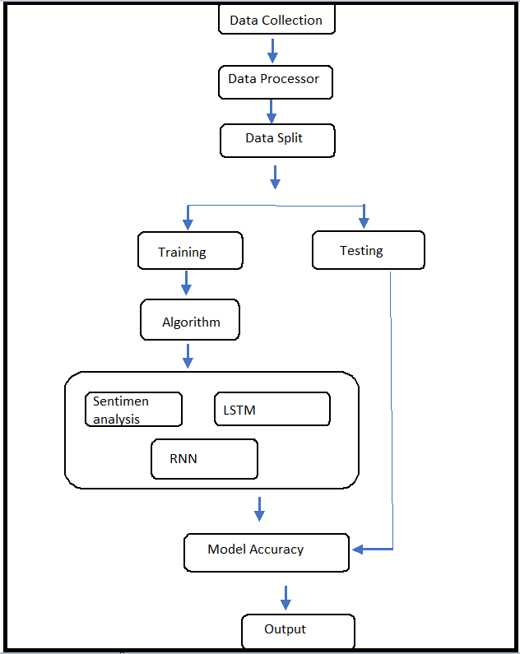

Fig 1:-UML Diagram of Proposed System

**Signup page**

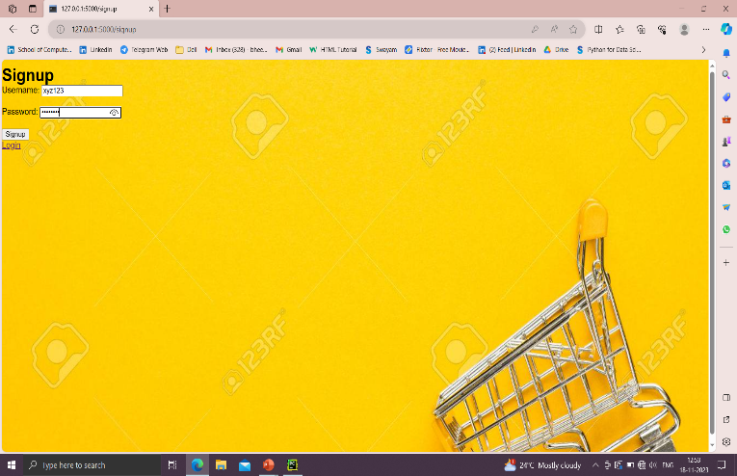

Fig 1:- Signup Page

User login

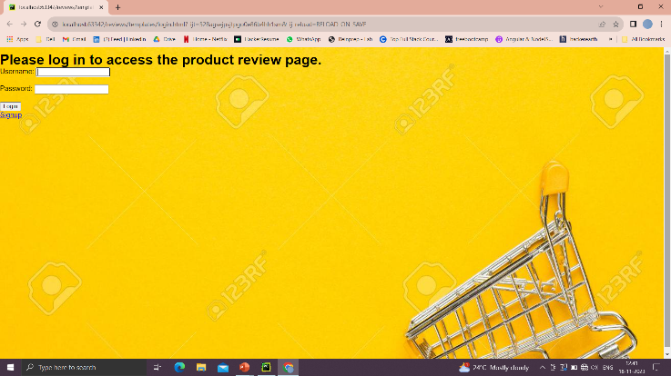

Fig 2:- Login page

Reviews page

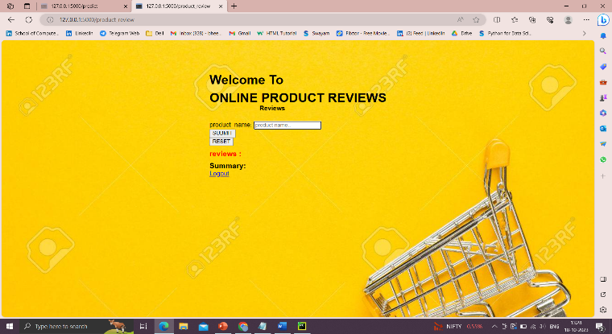

Fig 3:- Review page

Output page

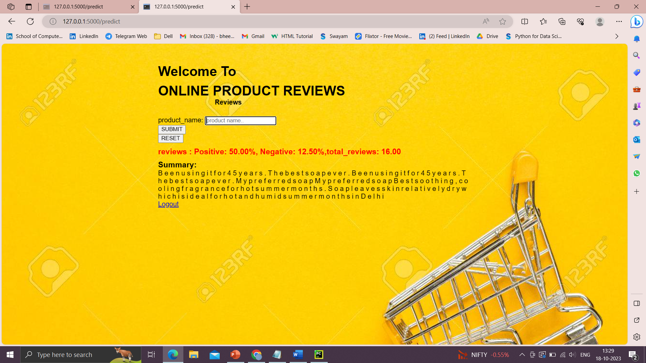

Fig 4:- Output page

1. RESULTS

the accuracy percentages for three algorithms using data from the "Kaggle". In this case, Random Forest performs well and 97% of the time correctly predicts the outcome. A Long Short Term Memory has a prediction accuracy of at least 75%. A Recurrent Neural Network (RNN) a prediction accuracy of at least 96%

The following table and figure show the outcomes after the proposed approach has been evaluated.

|  |  |  |
| --- | --- | --- |
| S.**No** | ***Classifiers*** | ***Accuracy*** |
| 1 | Random Forest | 97% |
| 2 | Long Short Term Memory | 75% |
| 3 | Recurrent Neural Network | 96% |

1. Accuracy of “ALL_Products_Review.csv” dataset in different models.

**V.CONCLUSION**

The study utilizes a dataset from Kaggle, comprising 5 attributes: product identification, name, date, rating, and review. This dataset, consisting of 2782 rows, is subjected to rigorous data preprocessing, including text cleaning, tokenization, and sentiment analysis to assess customer sentiments. The dataset is then divided into training, validation, and test sets to ensure robust model evaluation. Three machine learning algorithms are applied: Random Forest, Long Short-Term Memory (LSTM), and Recurrent Neural Network (RNN). The results show that Random Forest is capable of summarizing product reviews, with an accuracy rate of 97%. Moreover, accuracy rates of 75% and 96% are achieved using LSTM and RNN, respectively.

In conclusion, the study demonstrates how machine learning may be used to evaluate consumer opinions and summarize product reviews. For this reason, the Random Forest model is a potential candidate because of its exceptional accuracy. Even though some applications might need further research and development, these findings offer information that can be used to make wise choices in the e-commerce industry.

**VI. FUTURE SCOPE**

Technology is advancing day by day and there may come a time when users could review a particular product by images, videos and gifs. So, to analyse, understand and extract the actual emotions behind those graphics we would need a separate and a more advanced model. That model would understand what the graphic is saying and whether the feedback given is good, bad or neutral. The model would classify those images, videos and gifs separately according to their sentiment and then it would decide (rating) after aggregating all the weights of the sentiments concluded. Same condition might occur if there existed audio and sound feedbacks. In such case we might need an advanced model which can classify and segregate moods and sentiments according to the voice message. The model might work upon the tone of the voice and the words spoken. The use of voice to text converter can be done .

VII..REFERENCES

1. N Shafiyah, R Alsaqour, Hashim Shaker, O Alsaqour,https://www.researchgate.net/publication/259742588_Review_on_Electronic_Commerce
2. Liu, Chien-Liang, et al., Movie rating and review summarization in mobile environment. Systems, Man, and Cybernetics, Part C: IEEE Transactions on Applications and Reviews, Volume 42 issue 3, pp.397-407,2012.
3. Feldman, Ronen. Techniques and applications for sentiment analysis. Communications of the ACM 5, Volume 56 Issue4, pp.82-89,2013.
4. Hearst, Marti A., Susan T. Dumais, Edgar Osman, John Platt, and Bernhard Schoellkopf. Support vector machines. Intelligent Systems and their Applications, IEEE 13, Volume. 4, pp.18-28, 1998.
5. Pang, Bo, et al., Thumbs up? sentiment classification using machine learning techniques. In Proceedings of the ACL-02 conference on Empirical methods in natural
6. Ding, Xiaowen, et al., A holistic lexicon-based approach to opinion mining. Proceedings of the 2008 International Conference on Web Search and Data Mining. ACM, pp. 231-240, 2008.
7. Cui, Hang, et al., Comparative experiments on sentiment classification for online product reviews. Proceedings of the 21st national conference on Artificial intelligence (AAAI). Volume 2, pp 1265- 1270, 2006.
8. Jebaseeli, A, et al., A Survey on Sentiment Analysis of (Product) Reviews. International Journal of Computer Applications 47, Volume 11, pp36-39, 2012.
9. Wang, Min, et al., Research on sentiment analysis technology and polarity computation of sentiment words. Progress in Informatics and Computing (PIC), 2010 IEEE International Conference on. Vol. 1. IEEE, 2010
10. Mudinas, Andrius, et al., Combining lexicon and learning based approaches for concept-level sentiment analysis. Proceedings of the First International Workshop on Issues of Sentiment Discovery and Opinion Mining. ACM, pp330-333, 2012.
11. de Albornoz, et al. A joint model of feature mining and sentiment analysis for product review rating. Advances in information retrieval. Springer Berlin Heidelberg, pp.55-66, 2011.
12. Mattosinho, F., et al., Thesis on Mining Product Opinions and Reviews on the Web. Technische Universitat Dresden ,2010.
13. Pang, Bo, et al., Thesis on Opinion mining and sentiment analysis. Foundations and trends in information retrieval Volume1-2, pp 1-135,2008
14. Zhu, Jingbo, et al. Aspect-based opinion polling from customer reviews. IEEE Transactions on Affective Computing, Volume 2.1, pp.37-49, 2011.
15. Na, Jin-Cheon, et al., Effectiveness of simple linguistic processing in automatic sentiment classification of product reviews. Advances in Knowledge Organization Volume9, pp. 49-54, 2004.
16. Nasukawa, Tetsuya, et al., Sentiment analysis: Capturing favorability using natural language processing. In Proceedings of the 2nd international conference on Knowledge capture, ACM, pp. 70- 77, 2003.
17. Li, Shoushan, Zhongqing Wang, et al., Sentiment Classification with Polarity Shifting Detection. In Asian Language Processing (IALP), 2013 International Conference on, pp. 129-132. IEEE, 2013.
18. M. Karamibekr, A., et al., Oriented Sentiment Classification, Processed of the IEEE/WIC/ACM International Conferences on Web Intelligence and Intelligent Agent Technology (WI-IAT), Vol (1): pp. 327-331, 2012.
19. Melville, Prem, et al., Sentiment analysis of blogs by combining lexical knowledge with text classification. In Proceedings of the 15th ACM SIGKDD international conference on Knowledge discovery and data mining, pp. 1275-1284. ACM, 2009.
20. Abbasi, Ahmed, sentiment analysis in multiple languages: Feature selection for opinion classification in Web forums. mACM Transactions on Information Systems (TOIS) Volume 26 issue 3, pp.1- 12, 2008.
21. Hearst, Marti A., et al. "Support vector machines." IEEE Intelligent Systems and their applications 13.4 (1998): 18-28.
22. Amin, Shahid & Kansana, Keshav & Majid, Jenifur. (2016). A Review Paper on E-Commerce.
23. Miss. Mayuri G. Dabhade and Prof.Nitin Chopde,July 2020 ,A Result Review Analysis of Product Recommendation System in Domain Sensitive Manner https://api.semanticscholar.org/CorpusID:221351472
24. Kamble, Nitin,(November 2021) Product Recommendation System Using Machine Learning. International Journal of Innovative Research in Computer and Communication Engineering, https://ssrn.com/abstract=4245401